CLOUD

Q -1 ) We have to create the IMA user below are the steps to create the IMA user in aws.

BEFORE CREATING THE USER

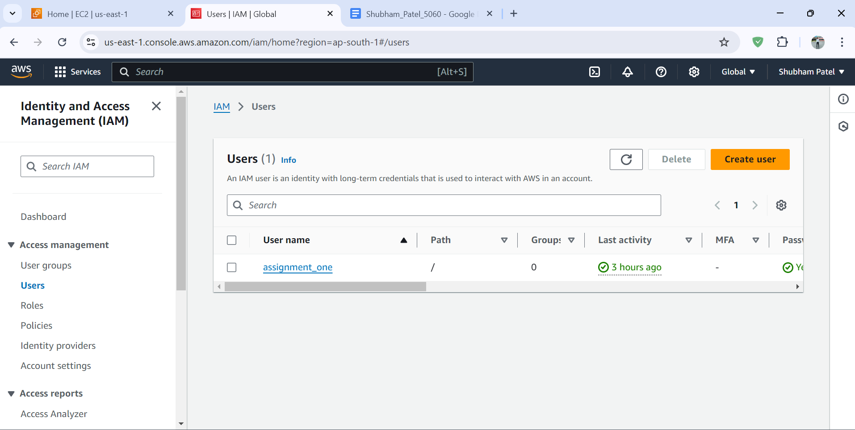

STEP - 1

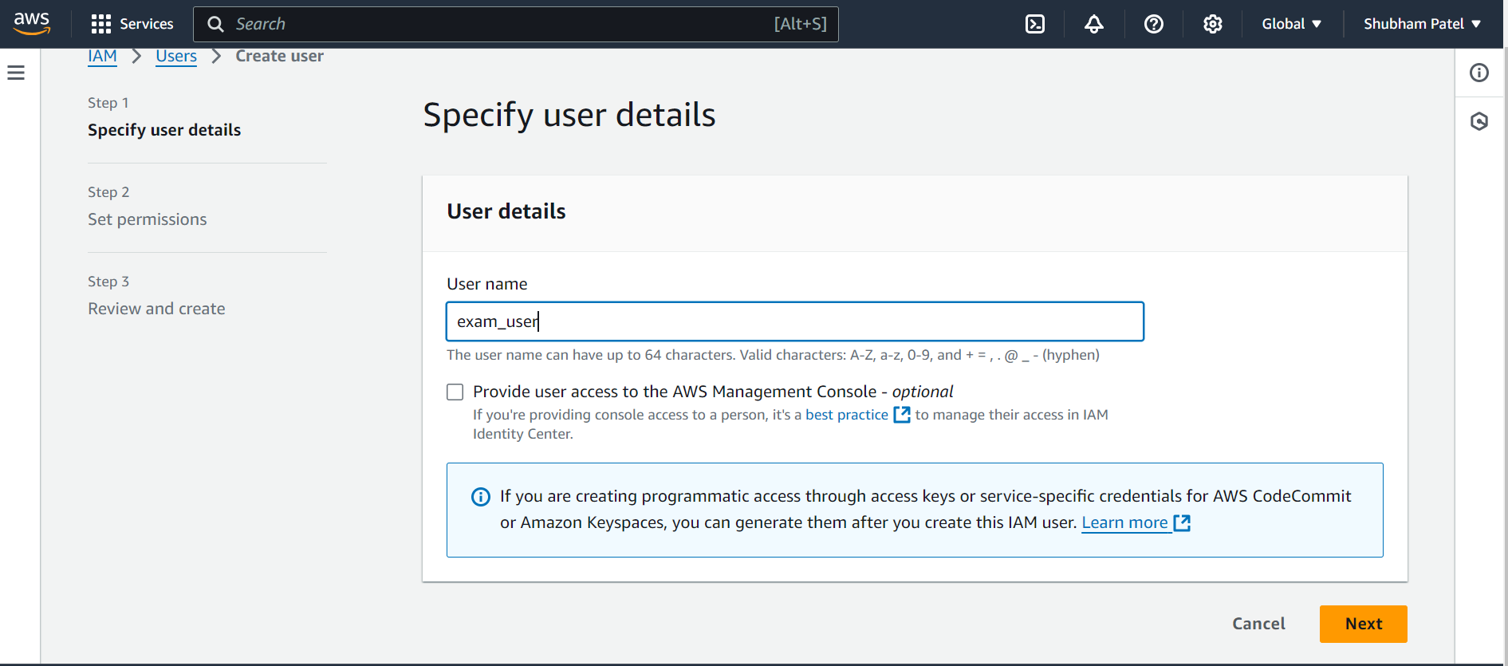

STEP - 2

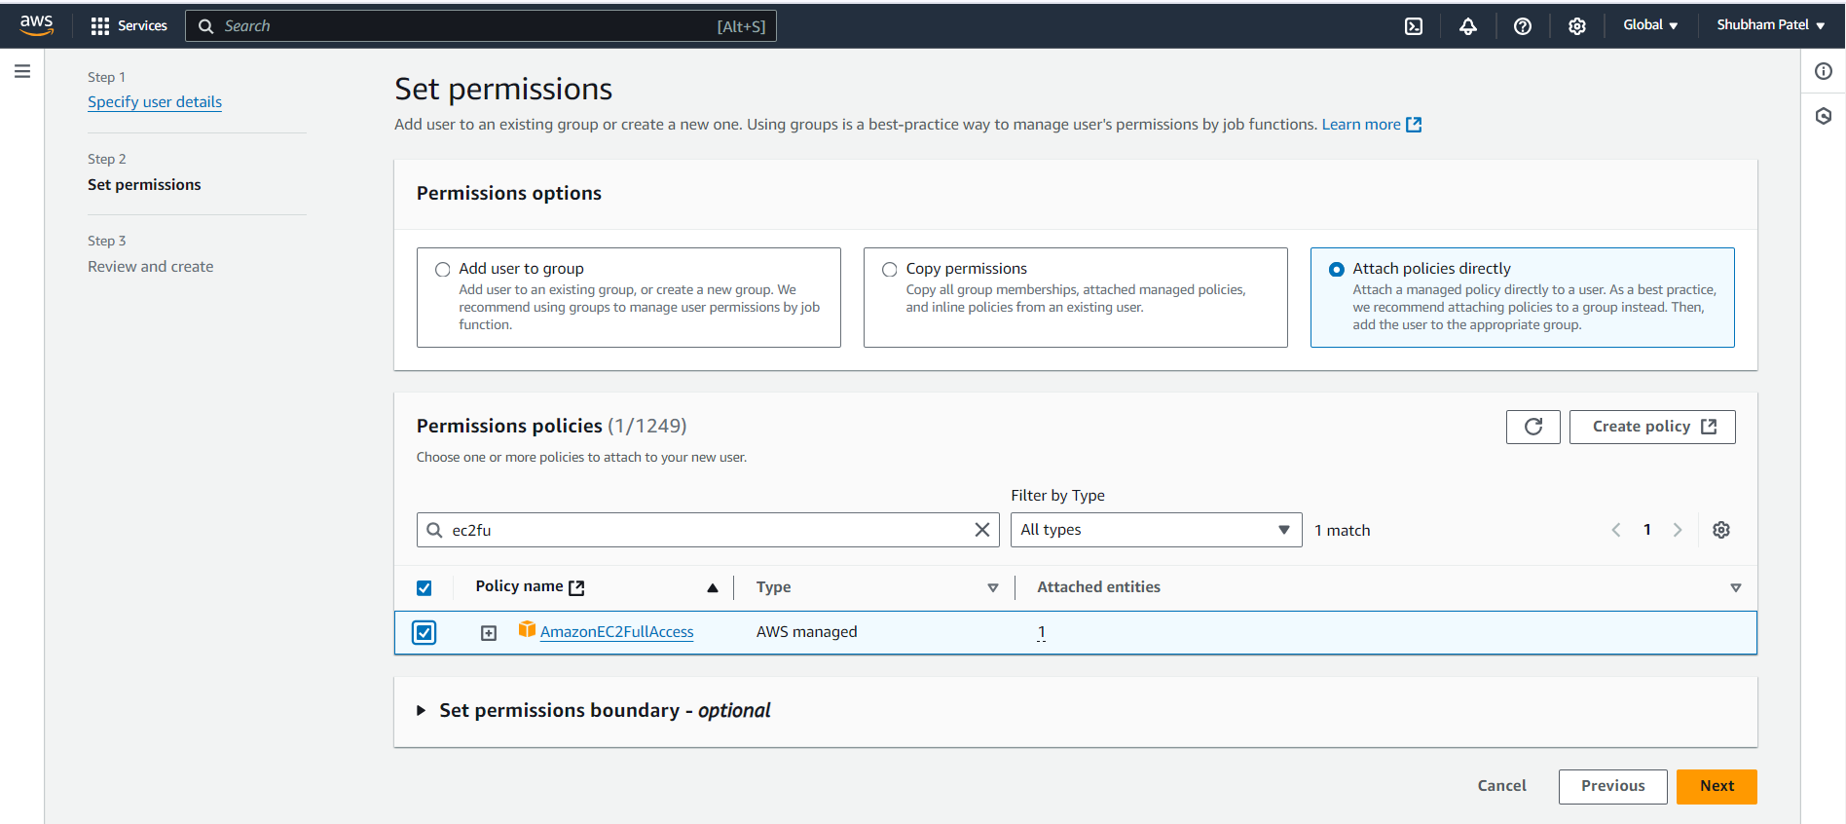

STEP - 3

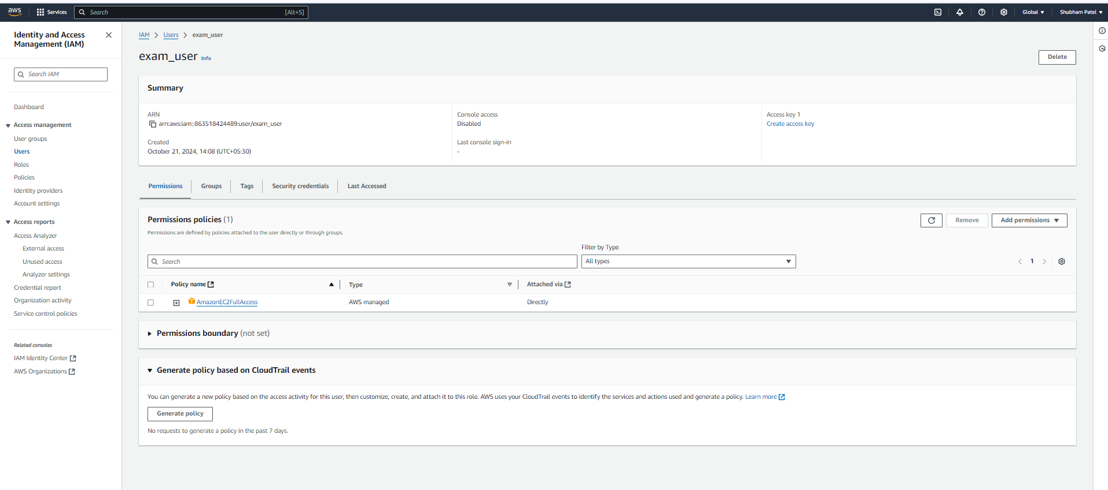

STEP - 4

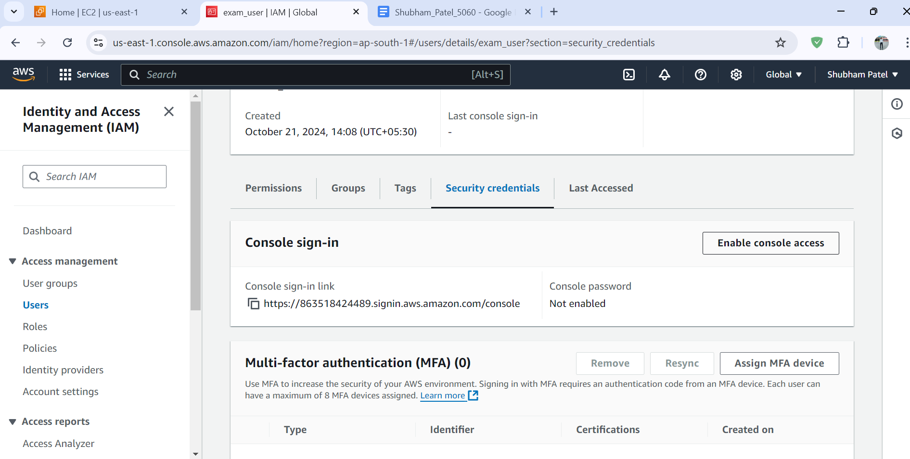

STEP -5

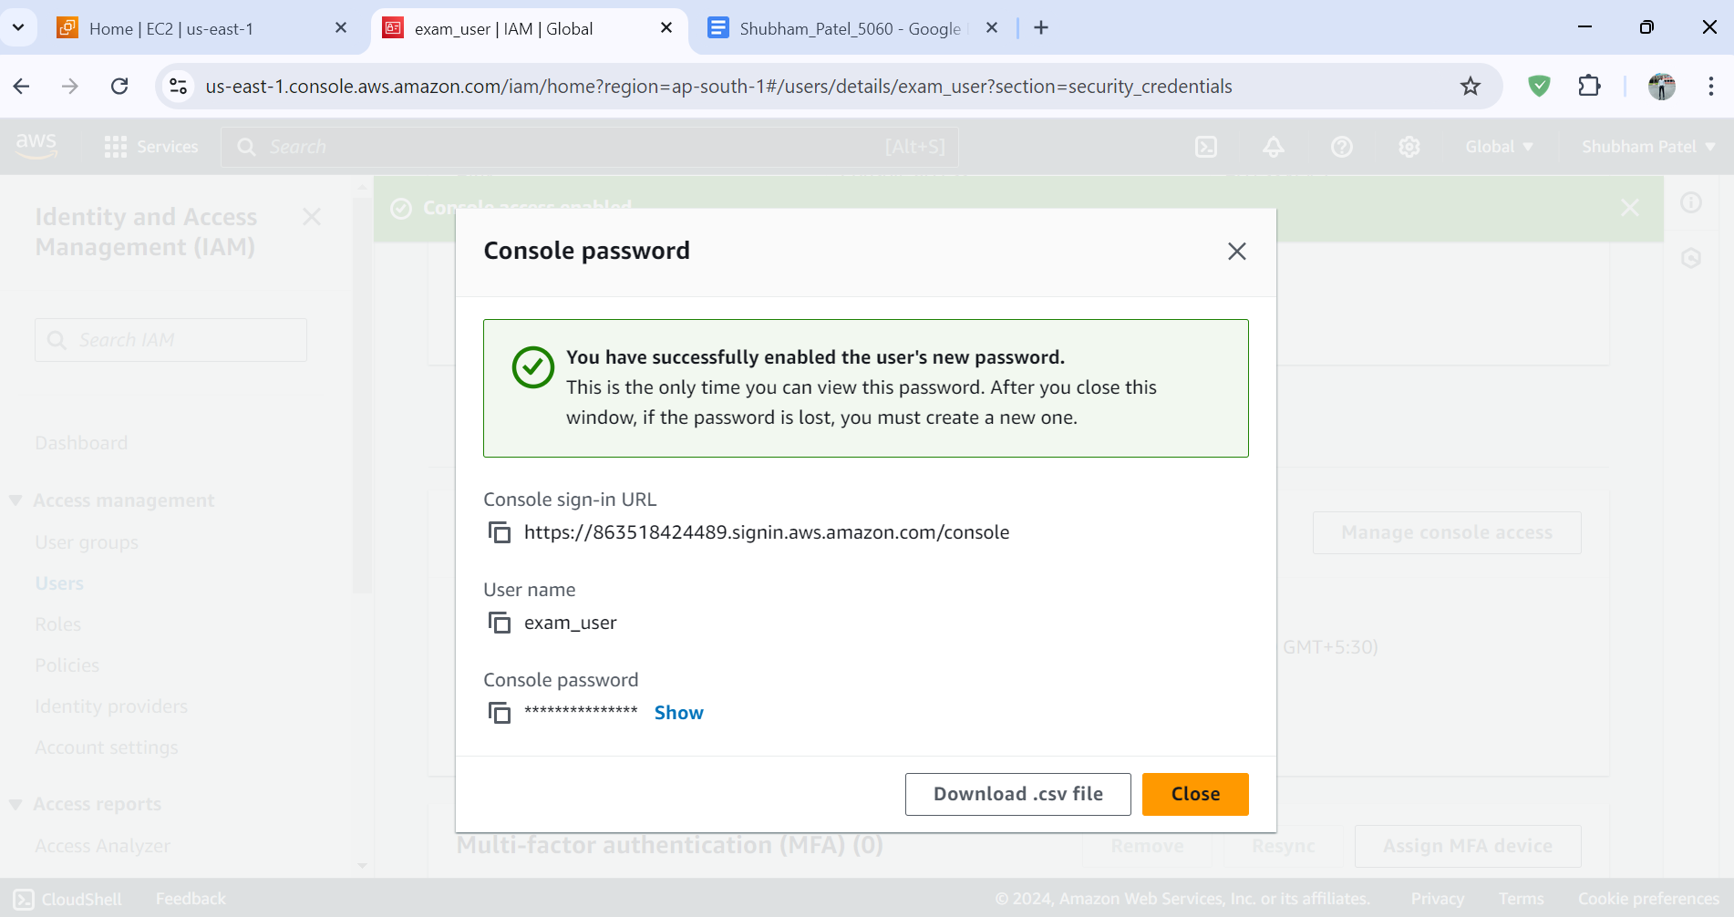

STEP -6

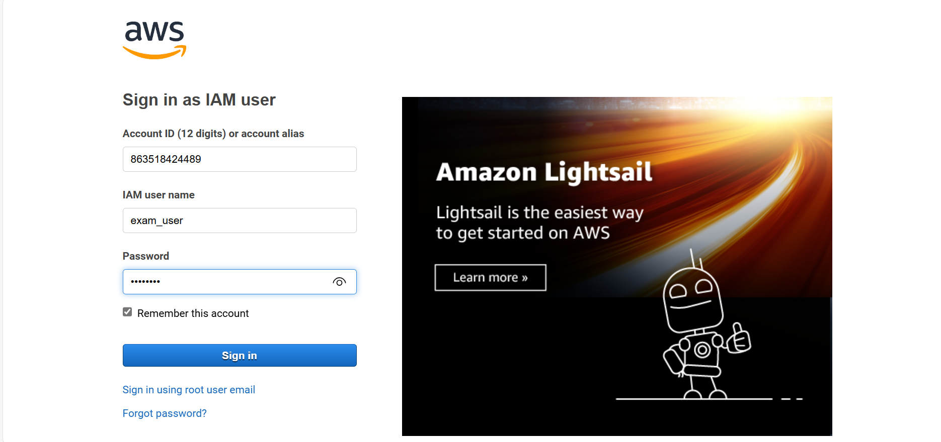

STEP - 7

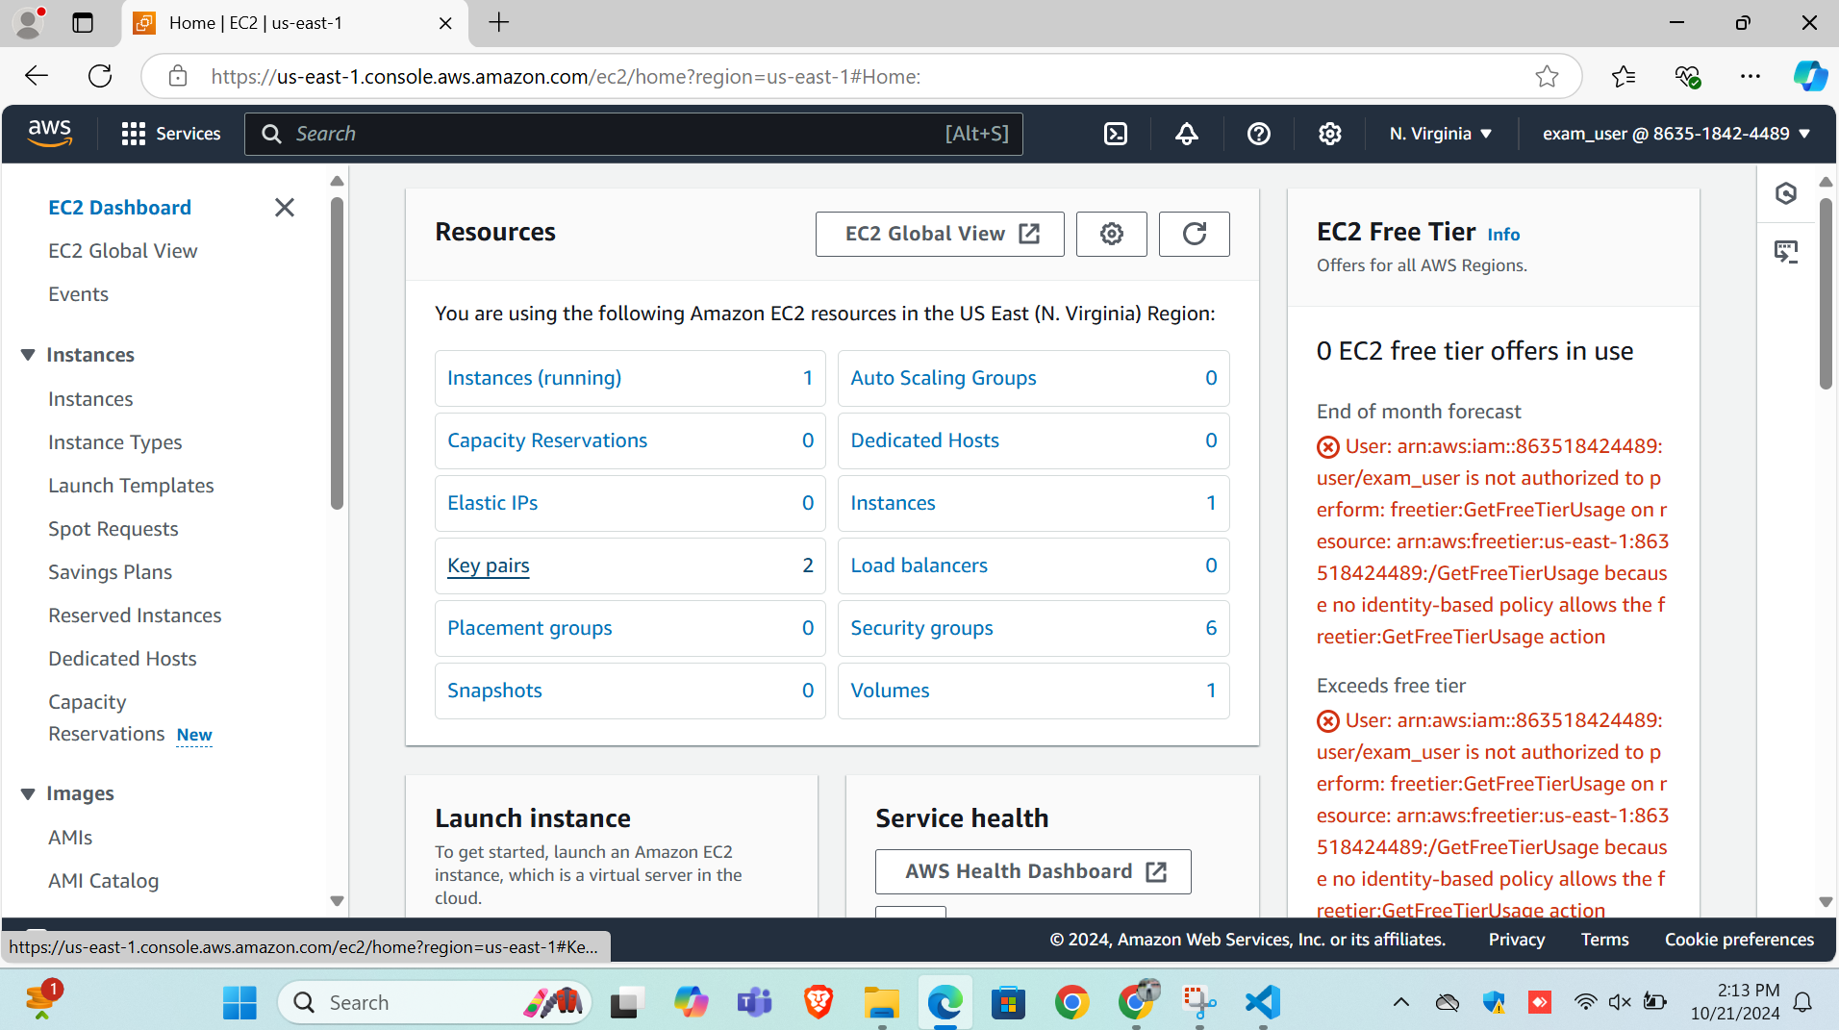

QUESTION -2

Step -1 Login with IMA user Here



Step -2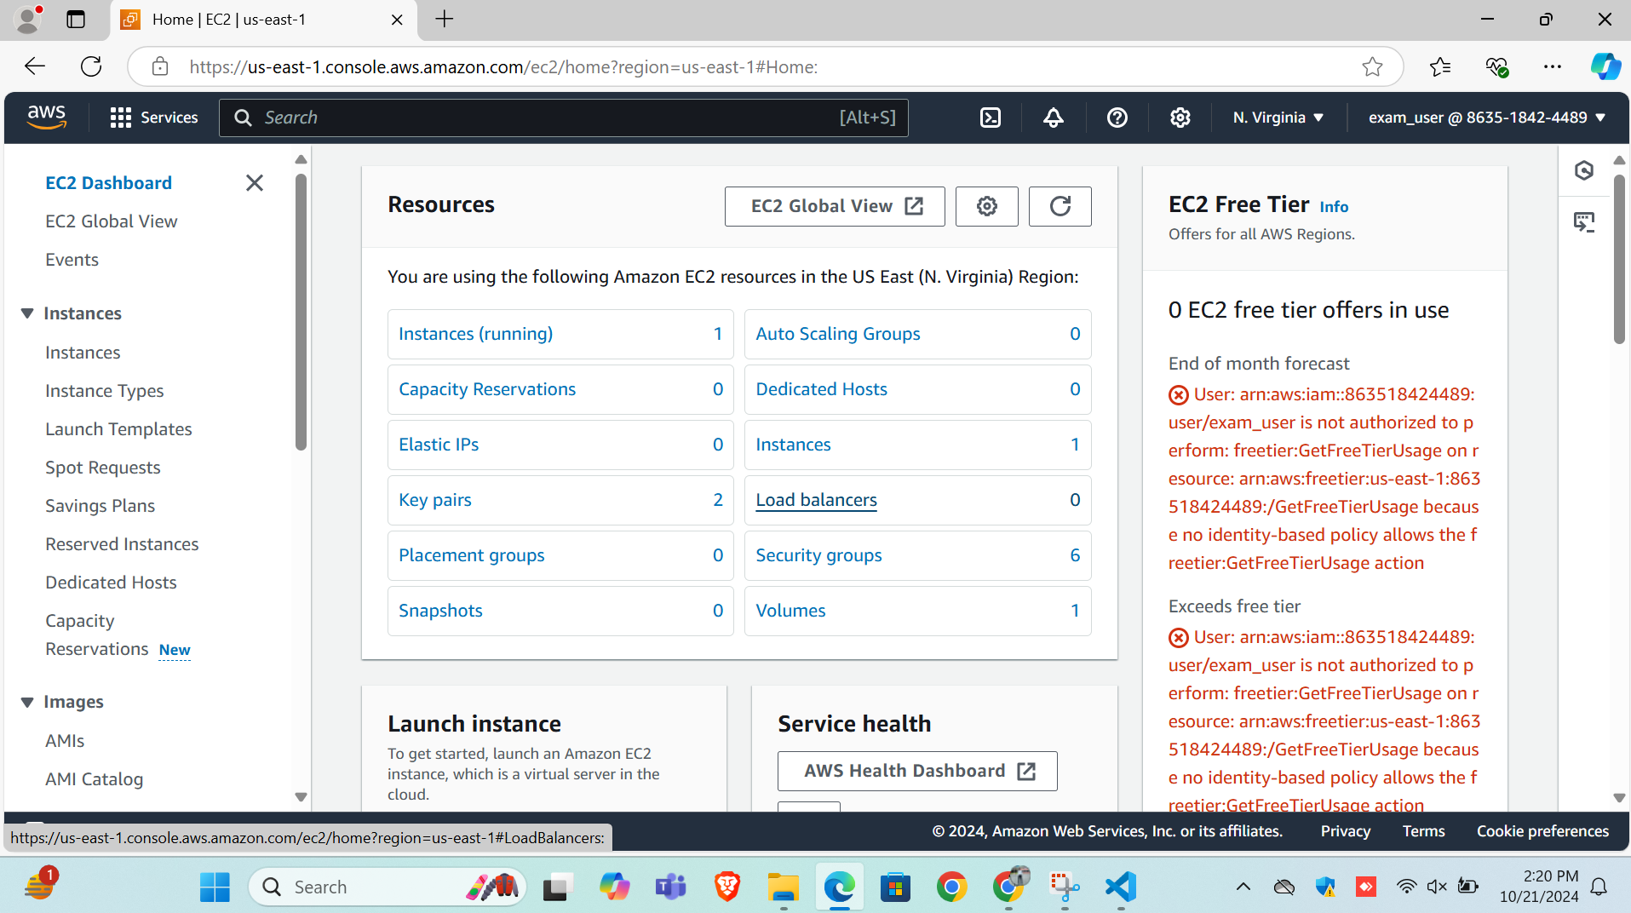

Step -3

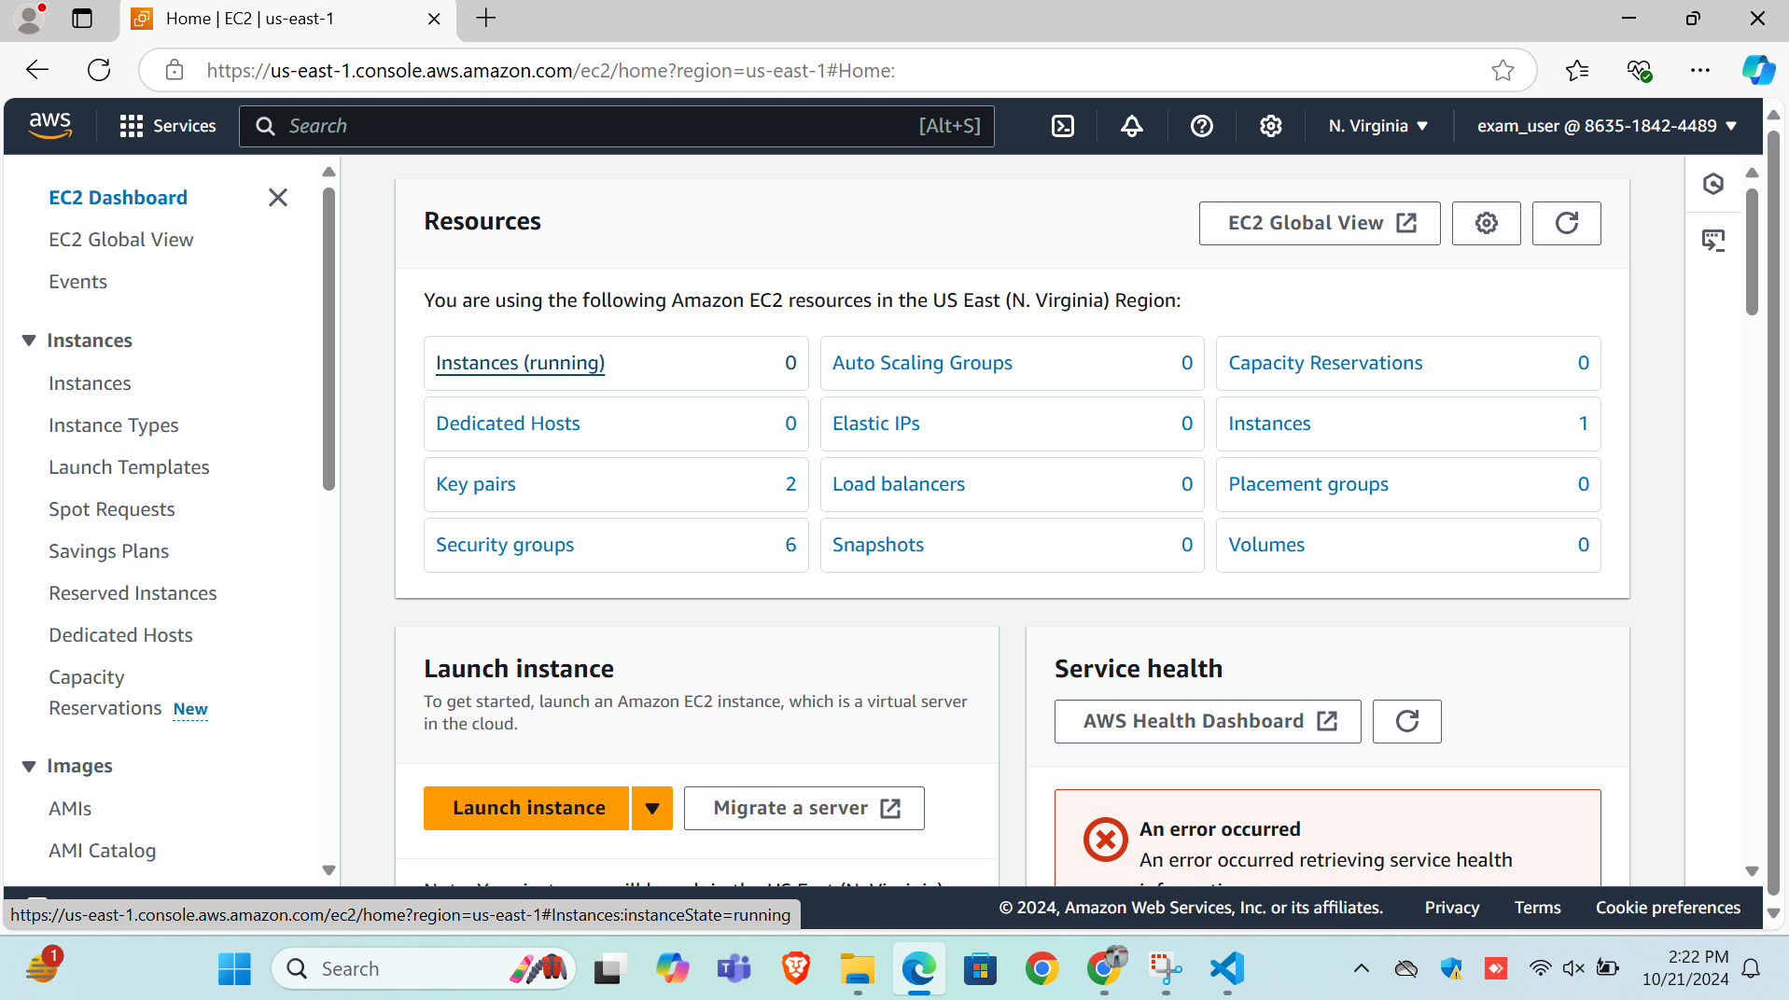

Step -3 Instance creation with IMA user

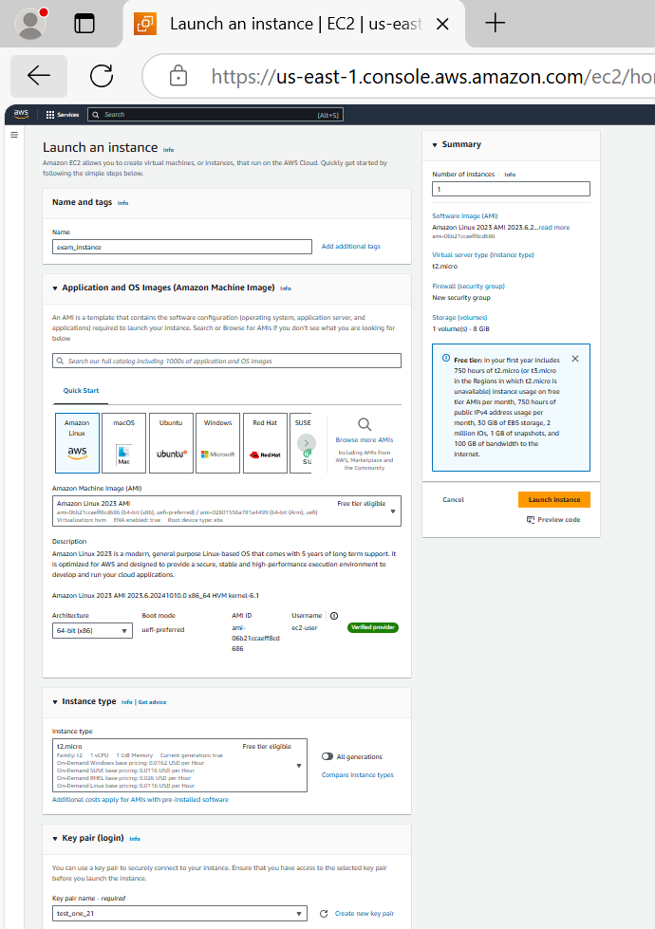

Step - 5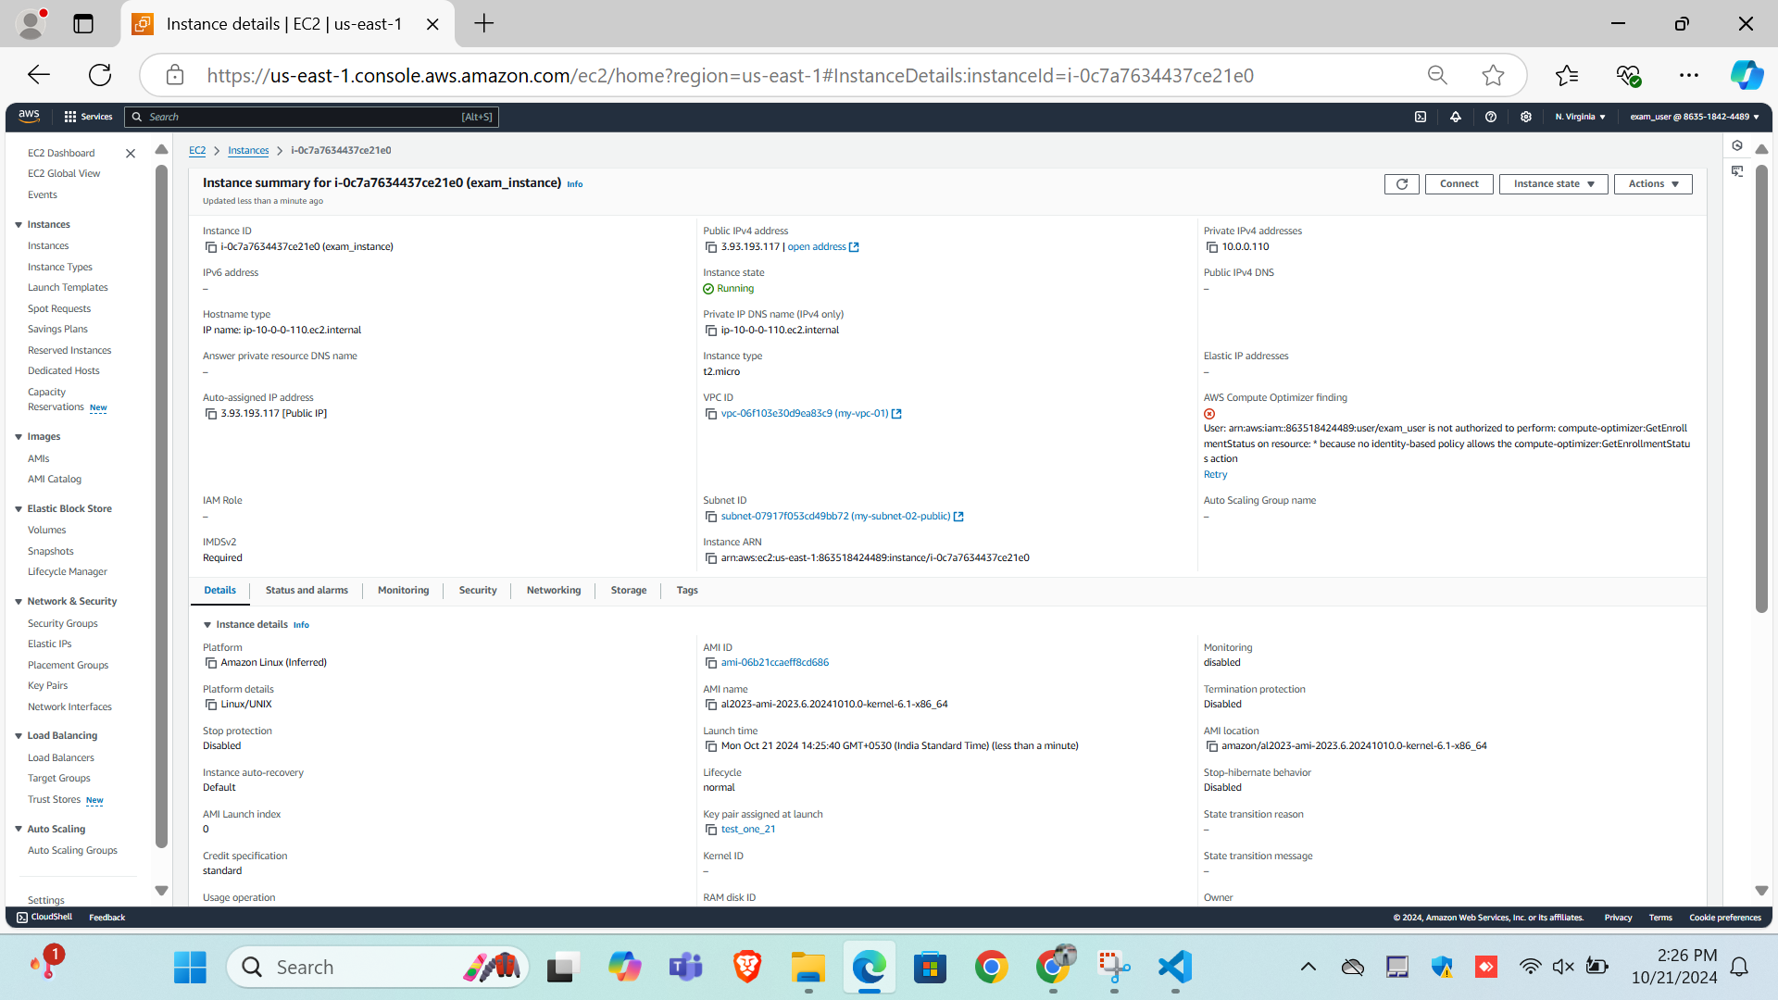

Step -6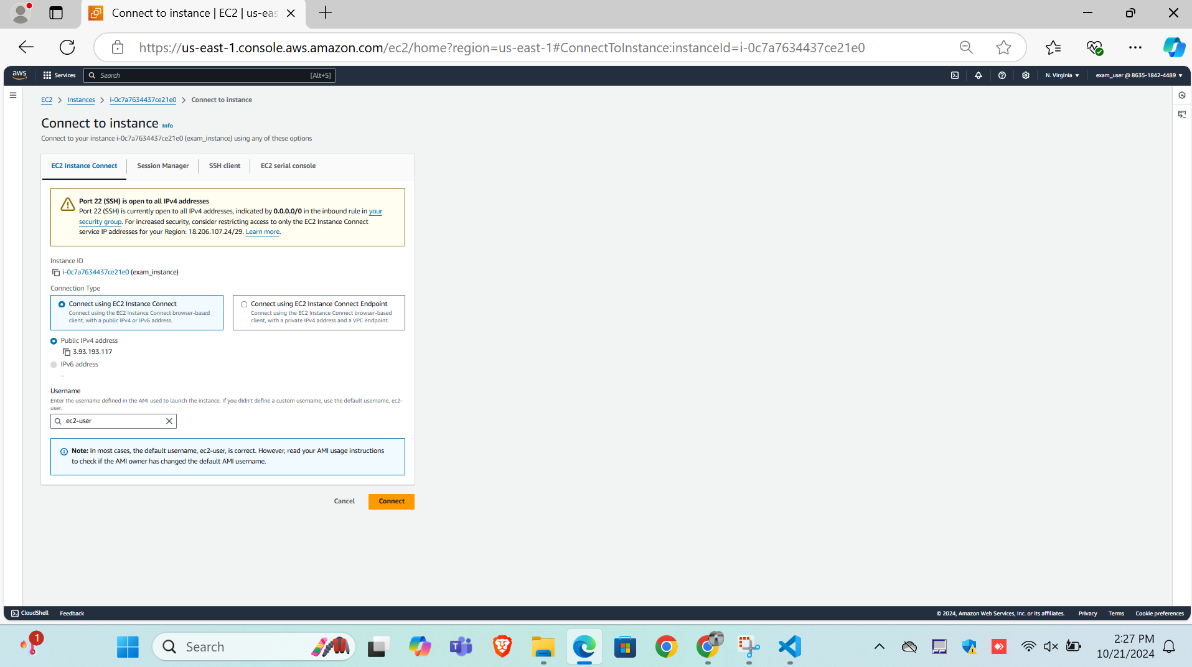

Step -7

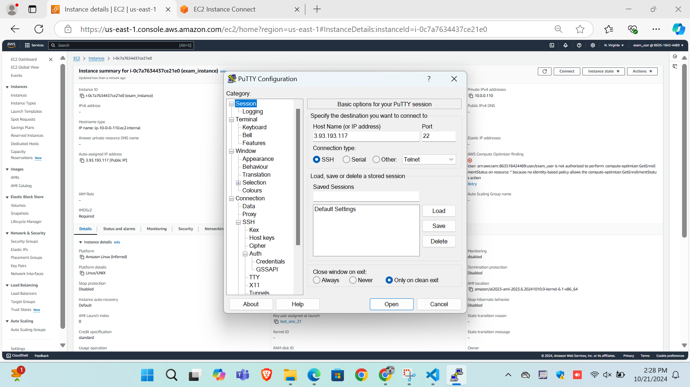

Step -8

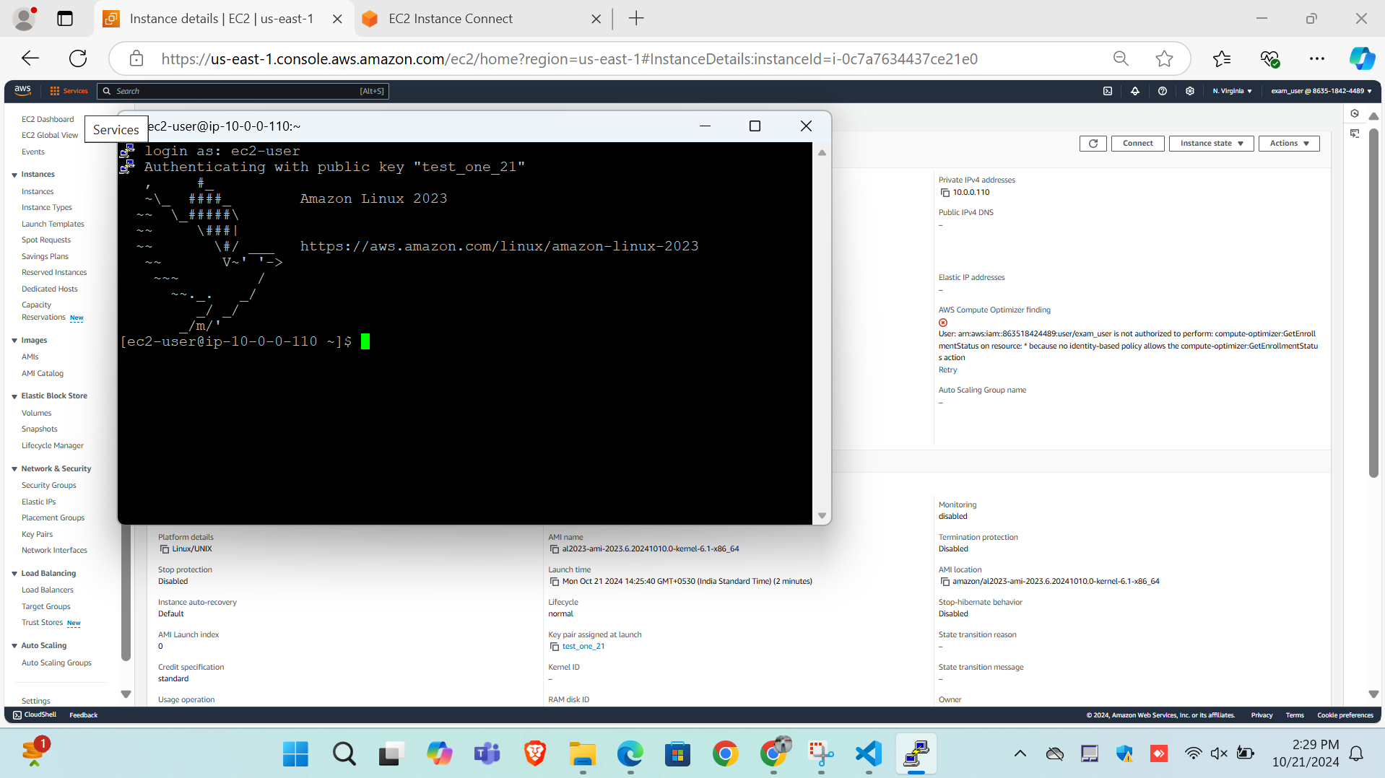

Step -9

Stopping the instance

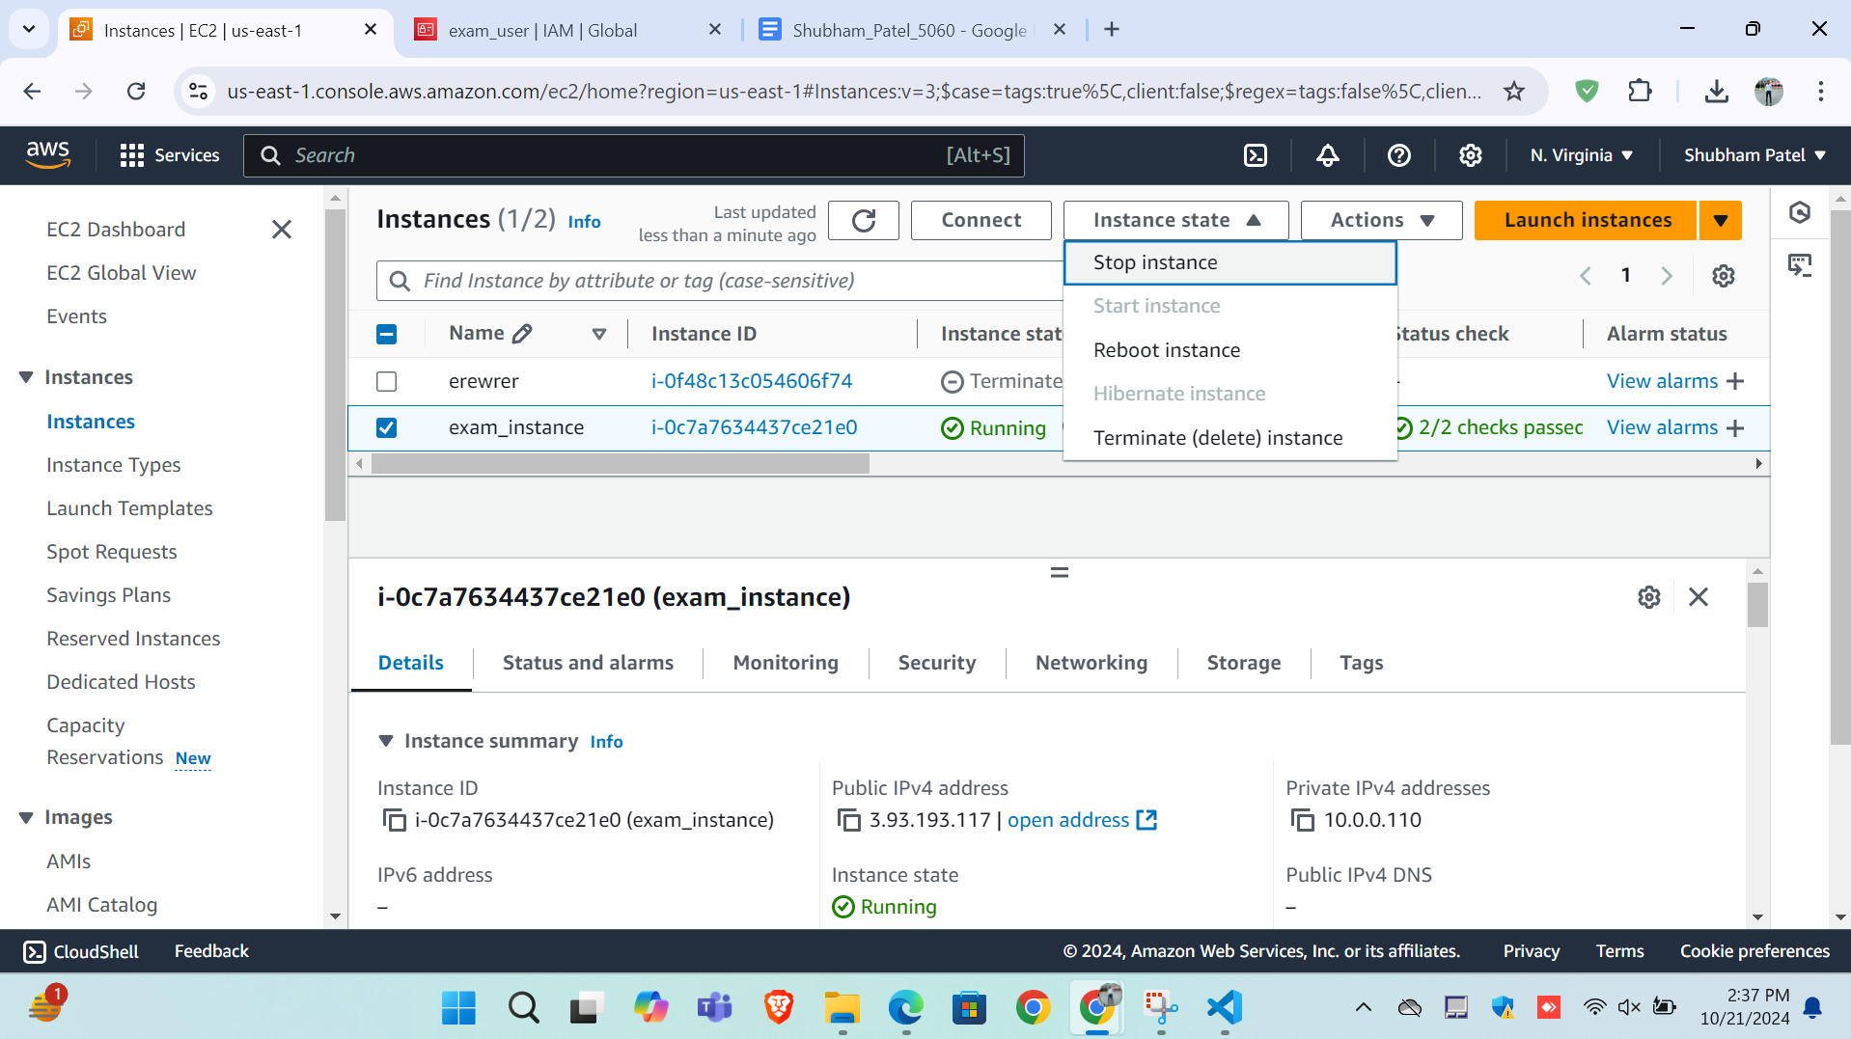

Step -10

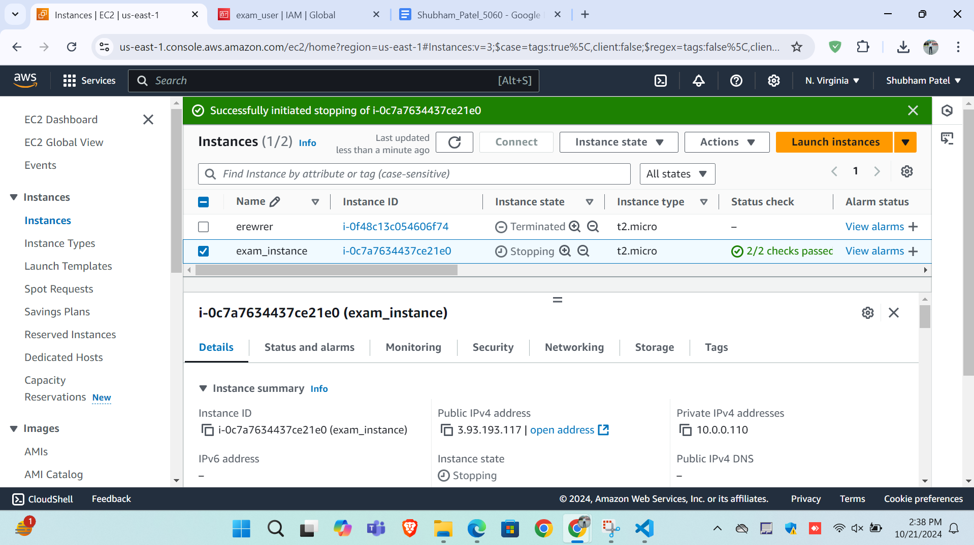

QUESTION - 3 & 4

Step -1

I gave s3 full access to my IMA user here. So it can create the s3 bucket also.

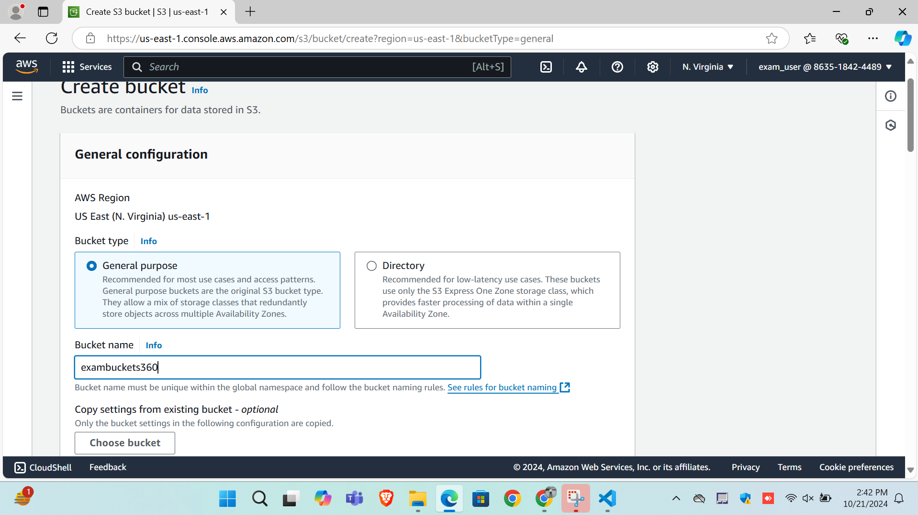

Step -2 Created Bucket here.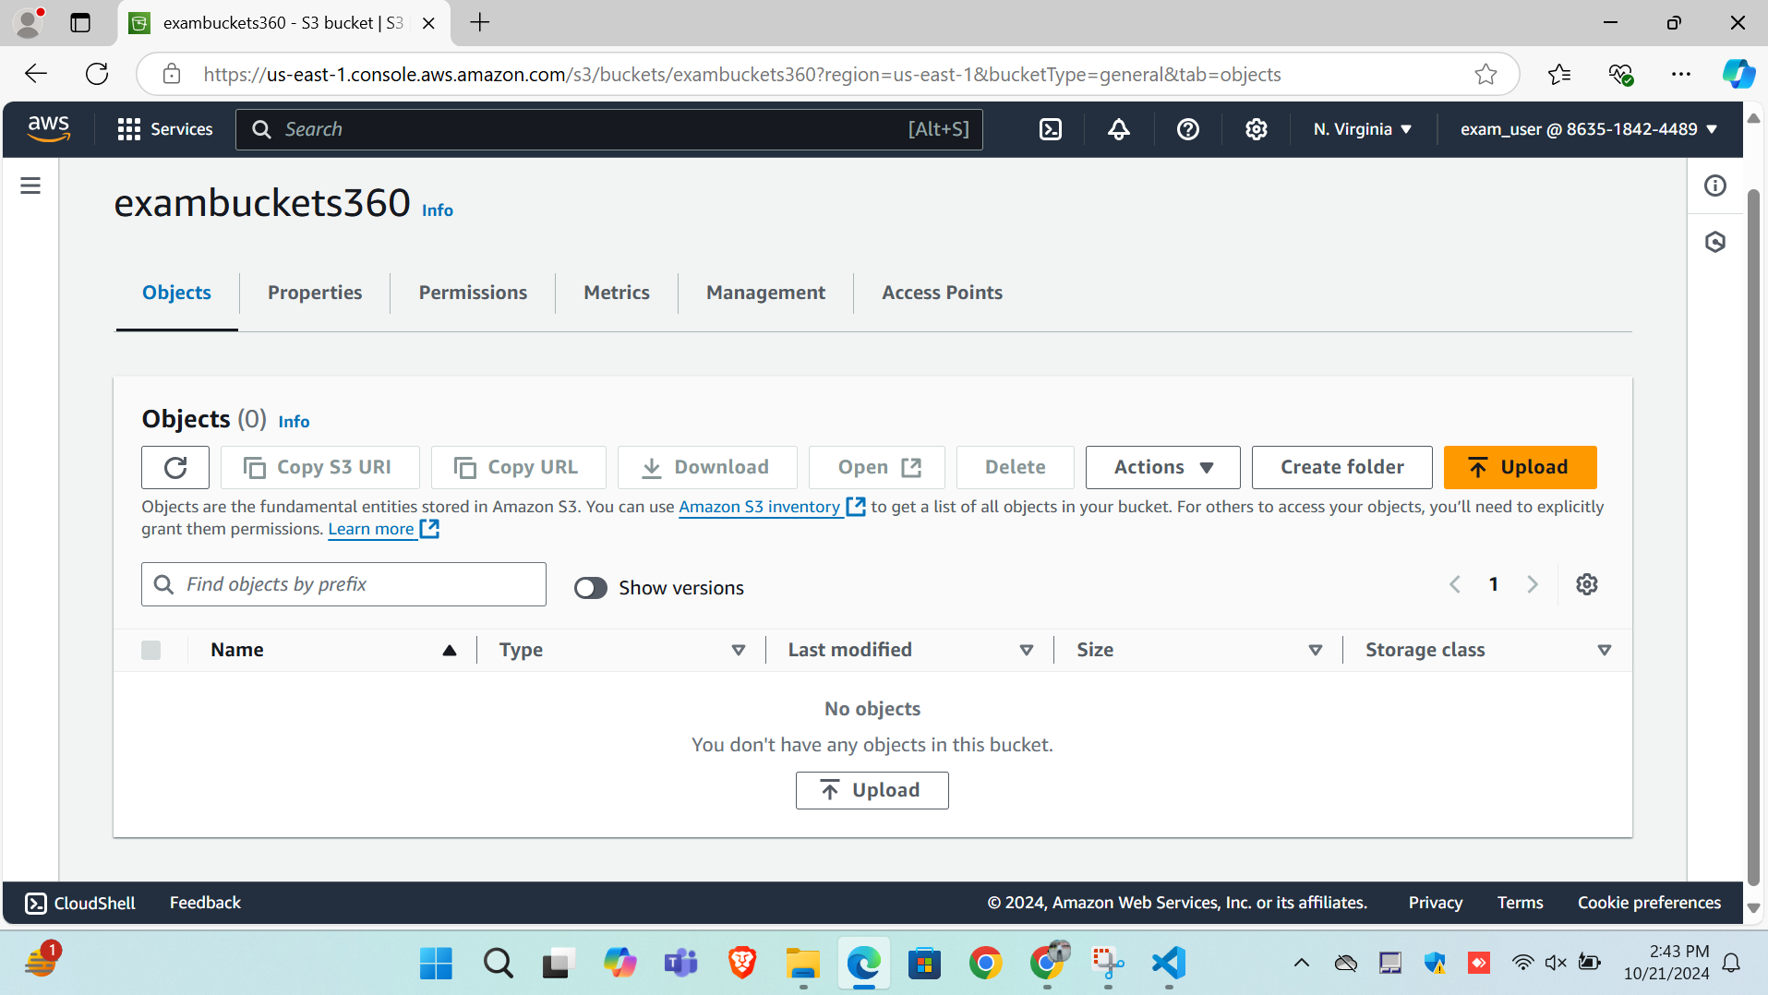

Step -3

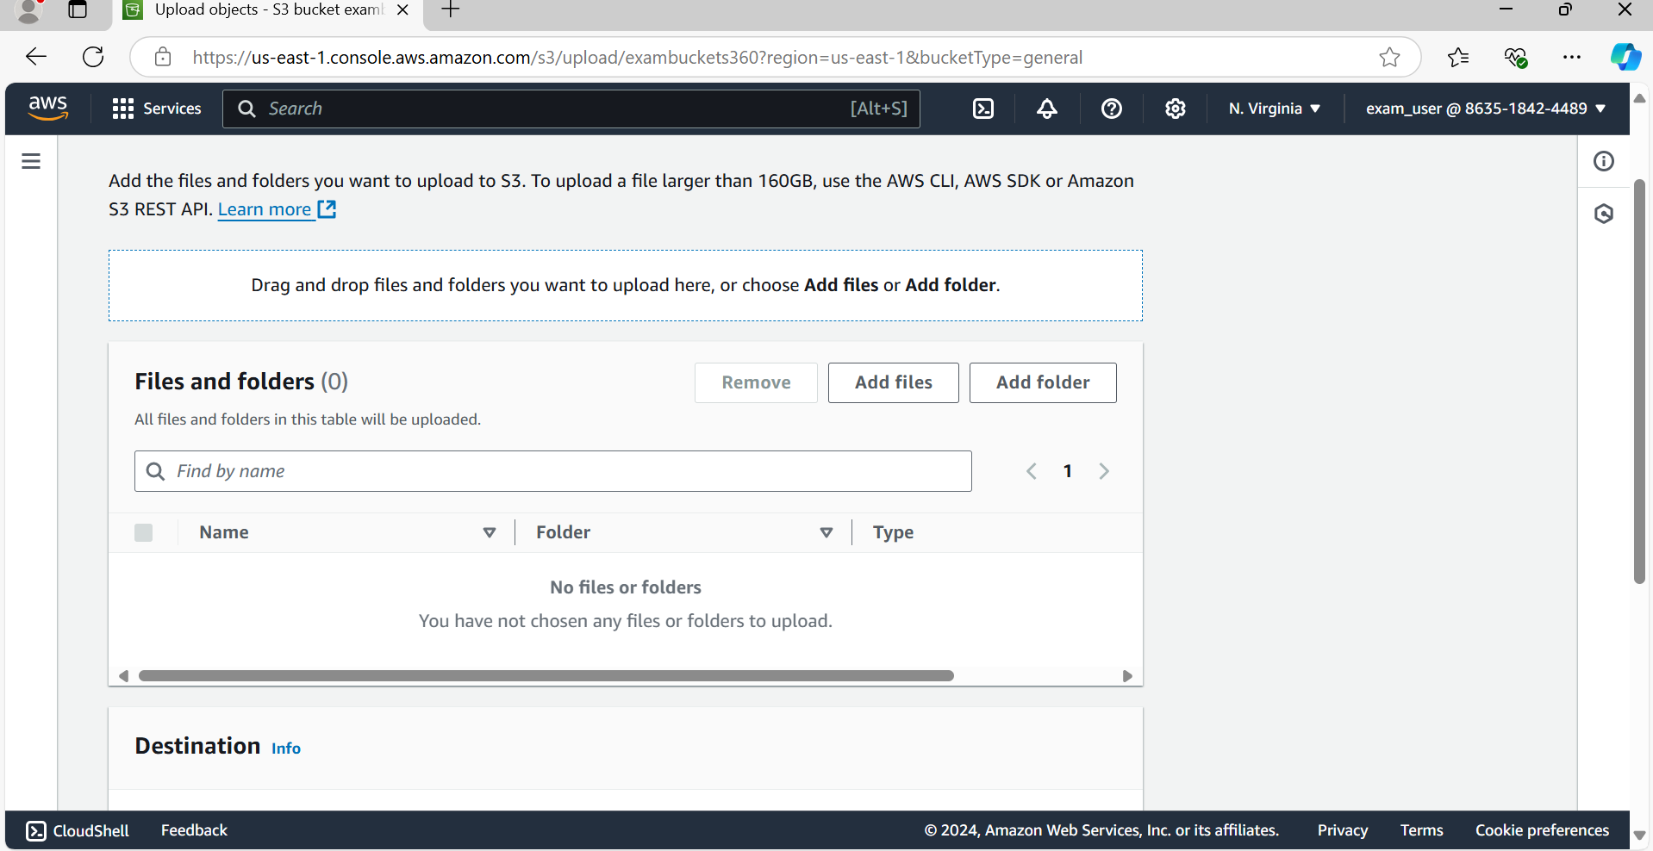

Step - 4 Upload the index.html file

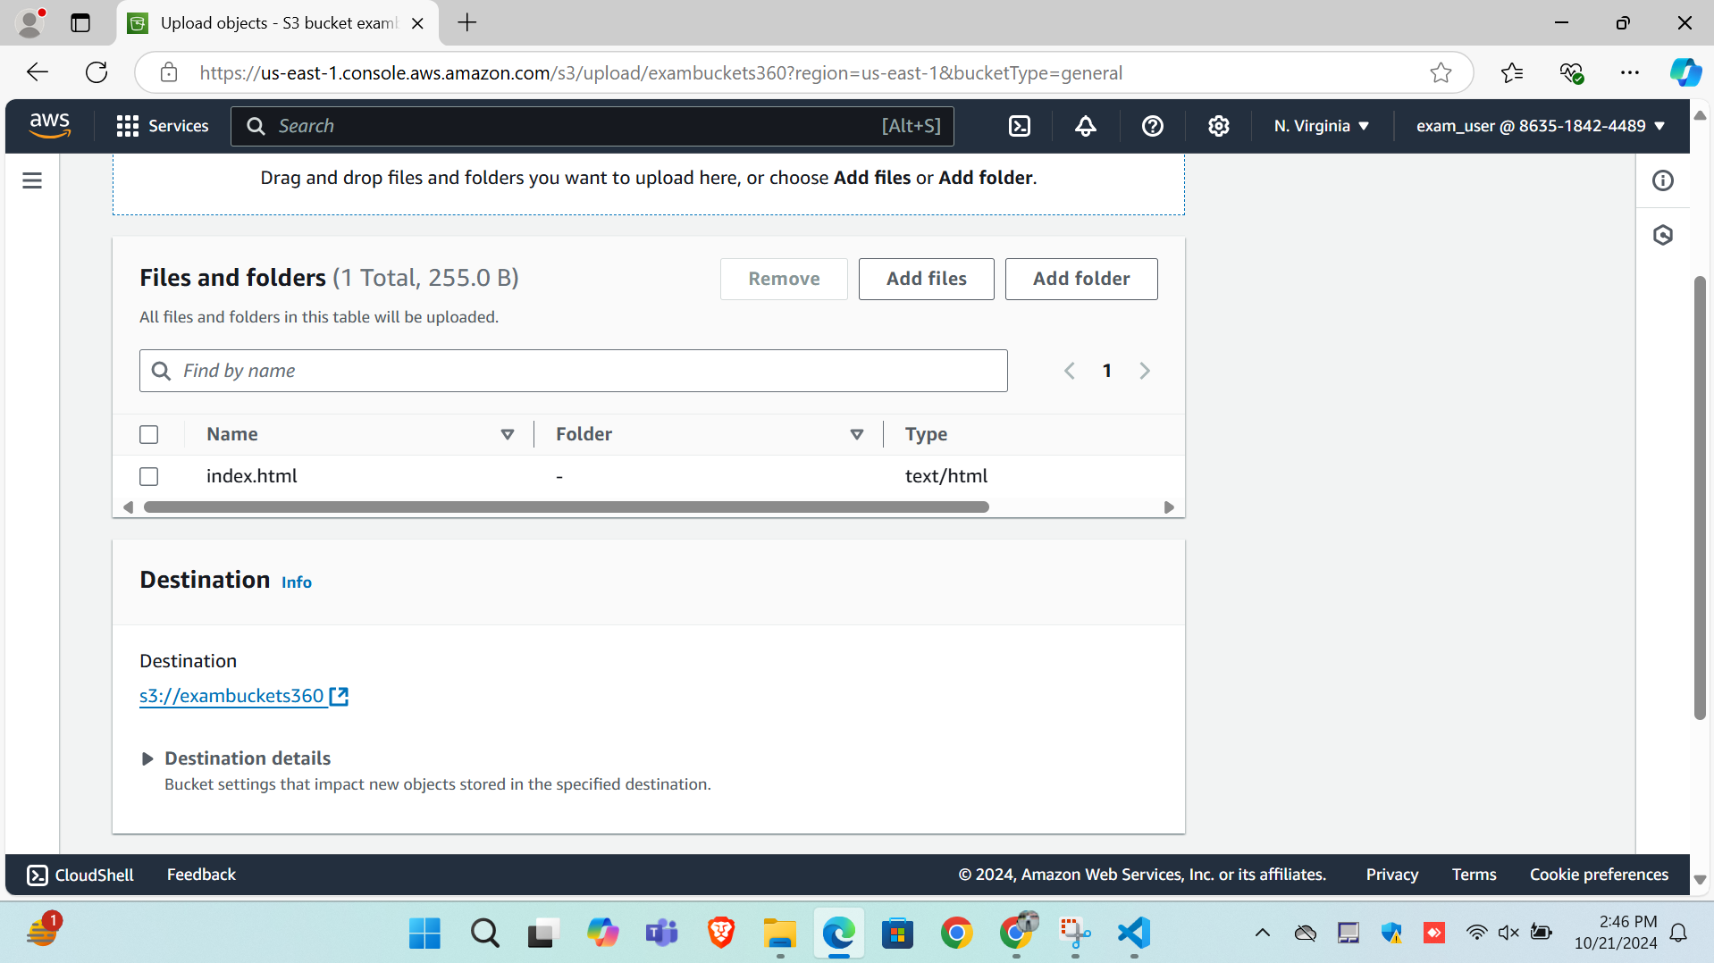

Step -5 Change the ACL Permission

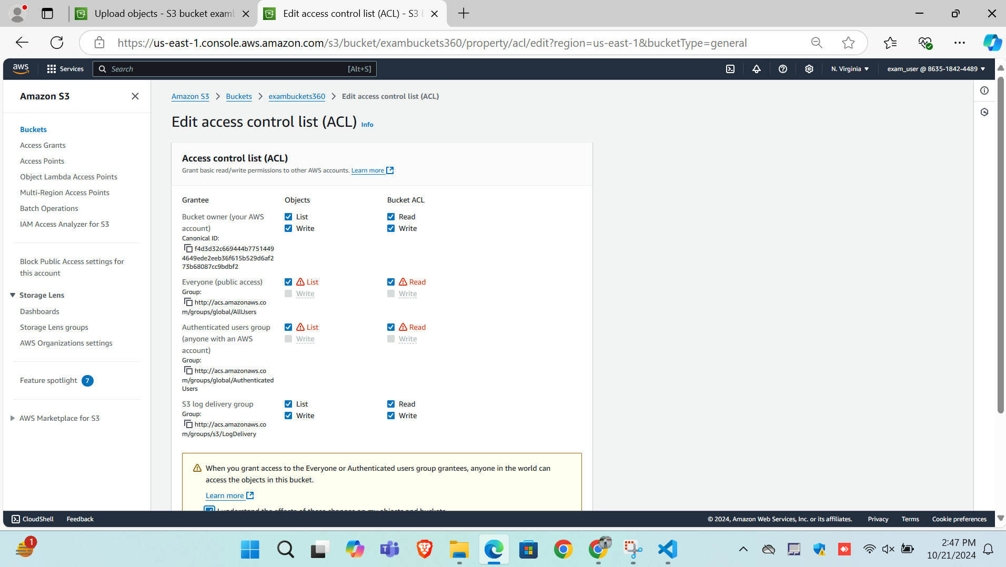

Step -6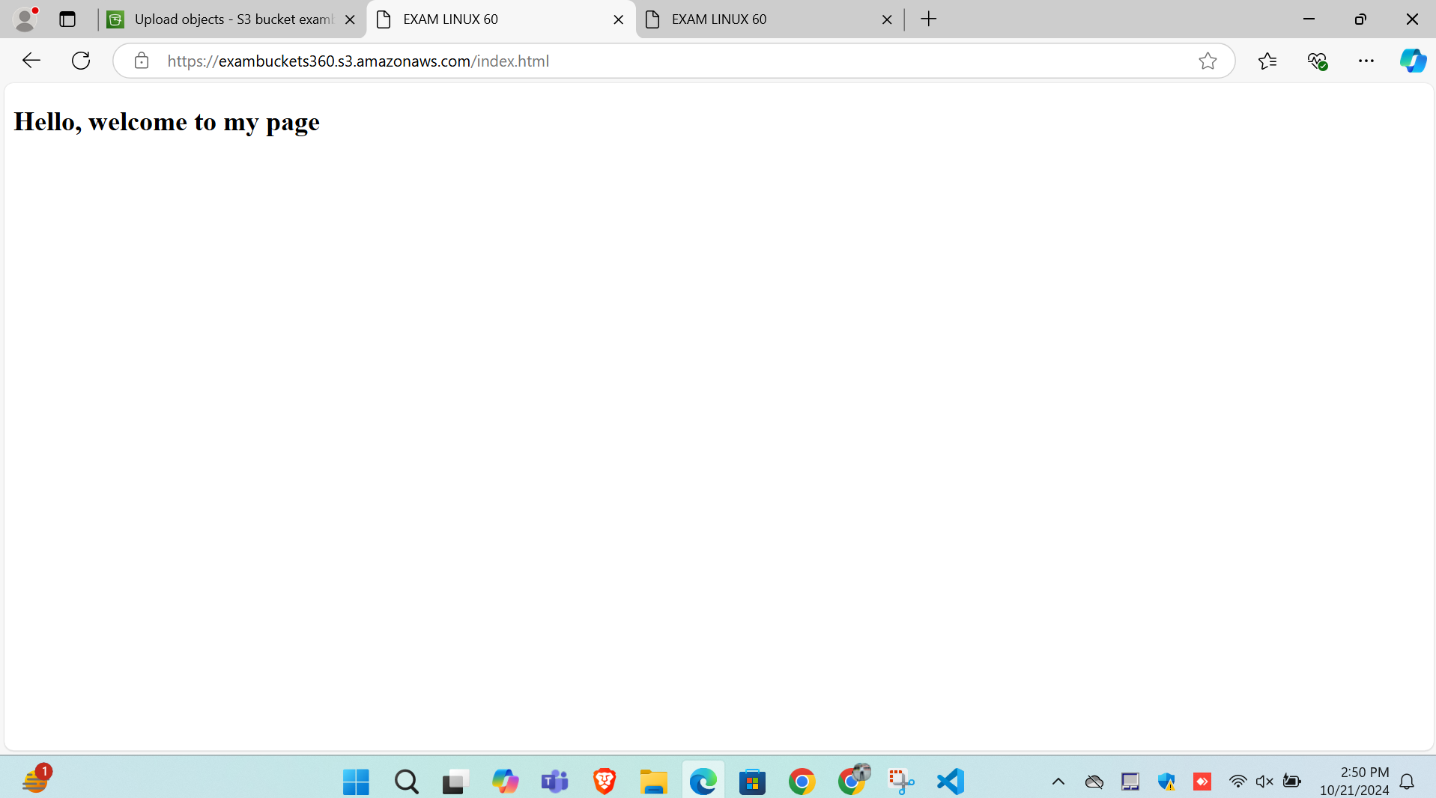

Bucket URL

<https://us-east-1.console.aws.amazon.com/s3/buckets/exambuckets360?region=us-east-1&bucketType=general&tab=objects>

Static Page

<https://exambuckets360.s3.amazonaws.com/index.html>

LINUX

Question 2)

2-a)make directory

[ec2-user@ip-172-31-9-57 ~]$ mkdir exam_dir

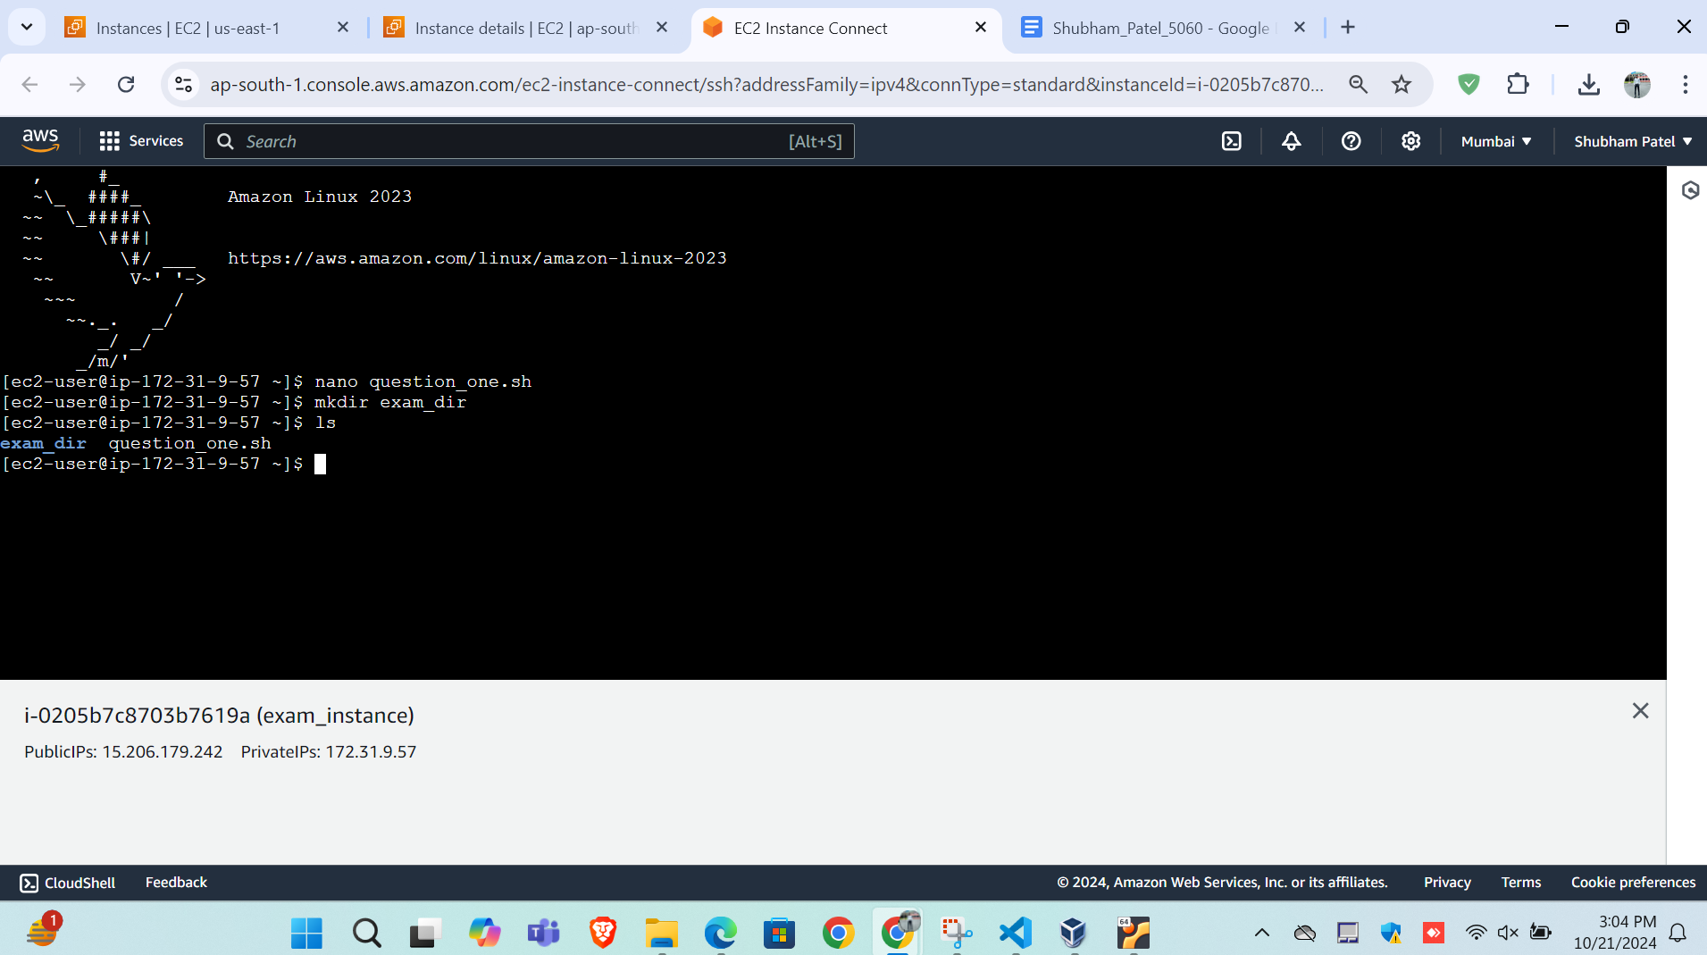

Question 2-c)

[ec2-user@ip-172-31-9-57 ~]$ mkdir exam_dir

[ec2-user@ip-172-31-9-57 ~]$ ls

exam_dir new_dir_happy question_one.sh

[ec2-user@ip-172-31-9-57 ~]$ mv exam_dir new_dir_happy

[ec2-user@ip-172-31-9-57 ~]$ cd new_dir_happy

[ec2-user@ip-172-31-9-57 new_dir_happy]$ ls

exam_dir

[ec2-user@ip-172-31-9-57 new_dir_happy]$ 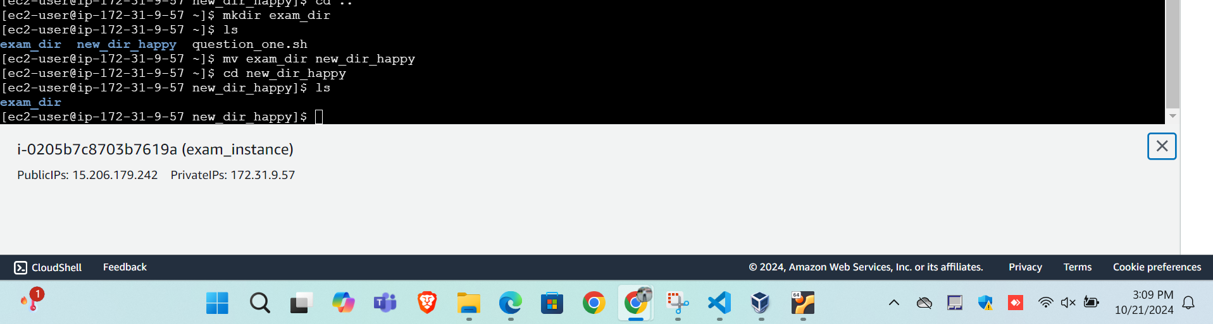

Question 2-d)

[ec2-user@ip-172-31-9-57 new_dir_happy]$ ls

Exam_dir

[ec2-user@ip-172-31-9-57 new_dir_happy]$ rmdir exam

rmdir: failed to remove 'exam': No such file or directory

[ec2-user@ip-172-31-9-57 new_dir_happy]$ rmdir exam_dir

[ec2-user@ip-172-31-9-57 new_dir_happy]$ ls

[ec2-user@ip-172-31-9-57 new_dir_happy]$ cd ..

[ec2-user@ip-172-31-9-57 ~]$ ls

new_dir_happy question_one.sh

[ec2-user@ip-172-31-9-57 ~]$ rmdir new_dir_happy

[ec2-user@ip-172-31-9-57 ~]$ ls

question_one.sh

[ec2-user@ip-172-31-9-57 ~]$ 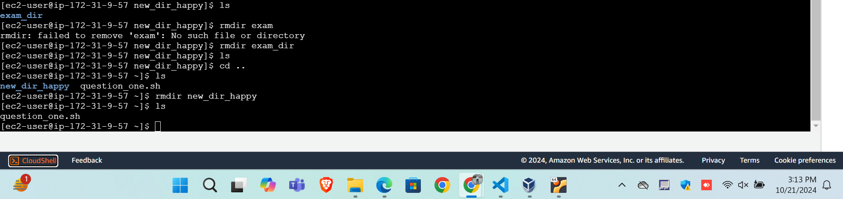

Question 2-e)

[ec2-user@ip-172-31-9-57 ~]$ mkdir hello_world

[ec2-user@ip-172-31-9-57 ~]$ chmod 54 hello_world